# Michael Lenehan - Assignment 7

## Question 1

**import java.awt.*;**

**import java.awt.event.*;**

**import javax.swing.*;**

**public class UpperLower implements ActionListener{**

**protected String in;**

**JFrame frame = new JFrame("UpperLower");**

**JTextField input = new JTextField(30);**

**JButton button = new JButton("Change Case");**

**public UpperLower()**

**{**

**frame.setLayout(new FlowLayout(FlowLayout.CENTER, 40, 20));**

**frame.add(input);**

**input.addActionListener(this);**

**frame.add(button);**

**button.addActionListener(this);**

**frame.pack();**

**frame.setDefaultCloseOperation(JFrame.EXIT_ON_CLOSE);**

**frame.setVisible(true);**

**}**

**public void actionPerformed(ActionEvent e)**

**{**

**if(e.getActionCommand().equals("Change Case"))**

**{**

**String in = input.getText();**

**input.setText(ChangeCase(in));**

**System.out.println(ChangeCase(in));**

**}**

**}**

**public static String ChangeCase(String str)**

**{**

**char[] c = str.toCharArray();**

**if(str.length() == 0)**

**return "Enter a String";**

**else**

**{**

**for(int i = 0; i<str.length()-1; i++)**

**{**

**if(Character.isLowerCase(str.charAt(i)))**

**{**

**c[i] = Character.toUpperCase(str.charAt(i));**

**}**

**else c[i] = Character.toLowerCase(str.charAt(i));**

**}**

**}**

**return str = String.valueOf(c);**

**}**

**public static void main(String args[])**

**{**

**new UpperLower();**

**}**

**}**

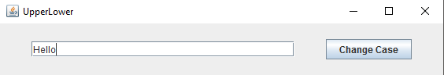

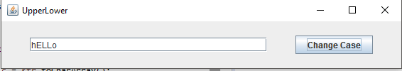

## Question 2

**import java.awt.*;**

**import java.awt.event.*;**

**import javax.swing.*;**

**public class Filter implements ActionListener{**

**protected String in, fil;**

**protected int i, j;**

**JFrame frame = new JFrame("String Filter");**

**JLabel l1 = new JLabel("Input String");**

**JTextField input = new JTextField(30);**

**JLabel l2 = new JLabel("Filter String");**

**JTextField filter = new JTextField(30);**

**JButton b1 = new JButton("Remove");**

**JButton b2 = new JButton("Keep Only");**

**public Filter()**

**{**

**frame.setLayout(new FlowLayout(FlowLayout.CENTER, 40, 20));**

**frame.add(l1);**

**frame.add(input);**

**input.addActionListener(this);**

**frame.add(l2);**

**frame.add(filter);**

**filter.addActionListener(this);**

**frame.add(b1);**

**b1.addActionListener(this);**

**frame.add(b2);**

**b2.addActionListener(this);**

**frame.pack();**

**frame.setDefaultCloseOperation(JFrame.EXIT_ON_CLOSE);**

**frame.setVisible(true);**

**}**

**public void actionPerformed(ActionEvent e)**

**{**

**String in = input.getText(), fil = filter.getText();**

**if(e.getActionCommand().equals("Remove"))**

**{**

**if(in.length() == 0) input.setText("Enter a String");**

**else**

**{**

**input.setText(in.replaceAll("[" +fil + "]+", ""));**

**}**

**}**

**if(e.getActionCommand().equals("Keep Only"))**

**{**

**if(in.length()==0) input.setText("Enter a String");**

**else**

**{**

**input.setText(in.replaceAll("[^" +fil + "]+", ""));**

**}**

**}**

**}**

**public static void main(String args[])**

**{**

**new Filter();**

**}**

**}**







## Question 3

**import java.awt.*;**

**import javax.swing.*;**

**public class RectangleComponent extends JComponent{**

**private int width, height;**

**private Color colour;**

**public RectangleComponent(int w, int h, Color c)**

**{**

**width = w;**

**height = h;**

**colour = c;**

**}**

**public void paintComponent(Graphics g)**

**{**

**g.setColor(colour);**

**g.fillRect(1, 1, width, height);**

**}**

**public static void main(String args[])**

**{**

**JFrame frame = new JFrame("Rectangle");**

**frame.add(new RectangleComponent(20, 20, Color.BLACK));**

**frame.setSize(200, 100);**

**frame.setDefaultCloseOperation(JFrame.EXIT_ON_CLOSE);**

**frame.setVisible(true);**

**}**

**}**

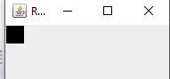

## Question 4

**import java.awt.*;**

**import java.awt.event.*;**

**import javax.swing.*;**

**public class RectangleComponent extends JComponent implements MouseListener{**

**private int width, height;**

**private Color colour;**

**public RectangleComponent(int w, int h, Color c)**

**{**

**width = w;**

**height = h;**

**colour = c;**

**this.addMouseListener(this);**

**}**

**public void paintComponent(Graphics g)**

**{**

**g.setColor(colour);**

**g.fillRect(1, 1, width, height);**

**}**

**public void mouseClicked(MouseEvent e)**

**{**

**if(colour == Color.BLACK)**

**{**

**colour = Color.WHITE;**

**repaint();**

**}**

**else**

**{**

**colour = Color.BLACK;**

**repaint();**

**}**

**}**

**public void mouseEntered(MouseEvent e){}**

**public void mouseExited(MouseEvent e){}**

**public void mousePressed(MouseEvent e){}**

**public void mouseReleased(MouseEvent e){}**

**public static void main(String args[])**

**{**

**JFrame frame = new JFrame("Rectangle");**

**RectangleComponent rect = new RectangleComponent(20, 20, Color.BLACK);**

**frame.add(rect);**

**frame.setSize(200, 200);**

**frame.setDefaultCloseOperation(JFrame.EXIT_ON_CLOSE);**

**frame.setVisible(true);**

**}**

**}**

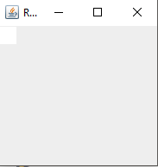

## Question 5

**import java.awt.*;**

**import java.awt.event.*;**

**import javax.swing.*;**

**public class RectangleComponent extends JComponent implements MouseListener{**

**private int width, height;**

**private Color colour;**

**public RectangleComponent(int w, int h, Color c)**

**{**

**width = w;**

**height = h;**

**colour = c;**

**this.addMouseListener(this);**

**}**

**public void paintComponent(Graphics g)**

**{**

**for(int i = 0; i<20; i++)**

**{**

**for(int j = 0; j<20; j++)**

**{**

**g.setColor(colour);**

**g.fillRect(1, 1, width, height);**

**}**

**}**

**}**

**public void mouseClicked(MouseEvent e)**

**{**

**if(colour == Color.BLACK)**

**{**

**colour = Color.WHITE;**

**repaint();**

**}**

**else**

**{**

**colour = Color.BLACK;**

**repaint();**

**}**

**}**

**public void mouseEntered(MouseEvent e){}**

**public void mouseExited(MouseEvent e){}**

**public void mousePressed(MouseEvent e){}**

**public void mouseReleased(MouseEvent e){}**

**public static void main(String args[])**

**{**

**JFrame frame = new JFrame("Rectangle");**

**frame.setLayout(new GridLayout(20, 20));**

**for(int i = 0; i<20*20; i++)**

**{**

**RectangleComponent rect = new RectangleComponent(200, 200, Color.BLACK);**

**frame.add(rect);**

**}**

**frame.setSize(1000, 1000);**

**frame.setDefaultCloseOperation(JFrame.EXIT_ON_CLOSE);**

**frame.setVisible(true);**

**}**

**}**

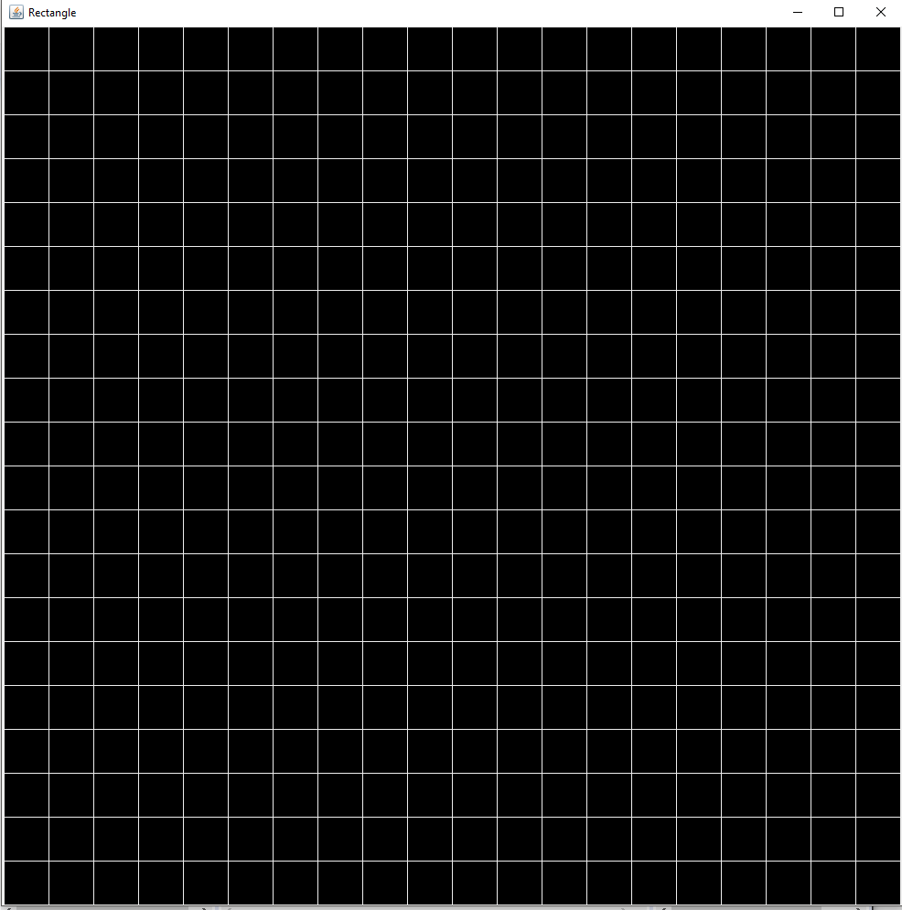

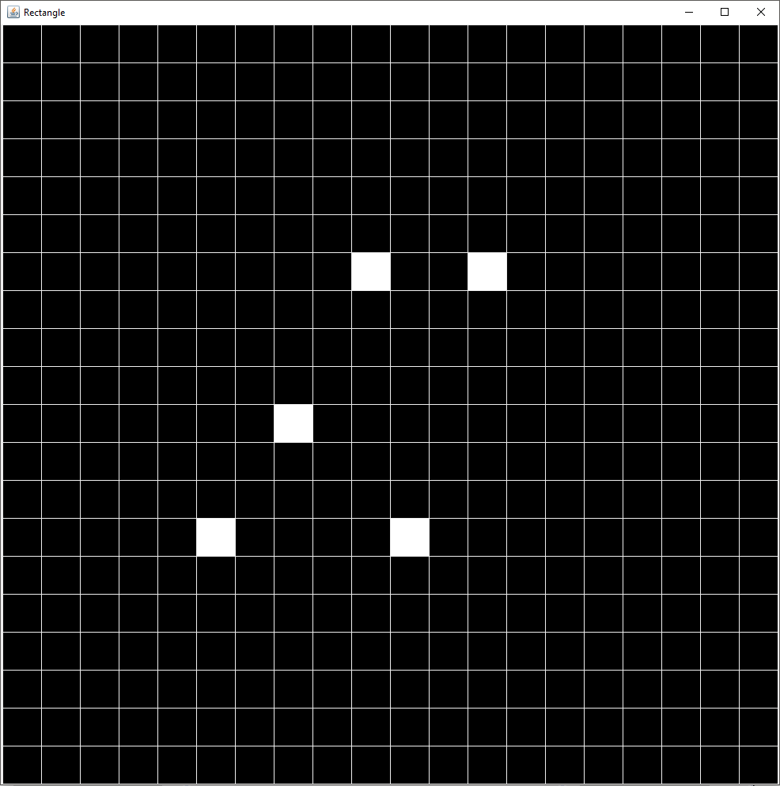

## Question 6

**import java.awt.*;**

**import java.awt.event.*;**

**import javax.swing.*;**

**public class RectangleComponent extends JComponent implements MouseListener, ActionListener{**

**private int width, height;**

**private Color colour;**

**static JFrame frame = new JFrame("Rectangle");**

**protected static JButton b = new JButton("Invert");**

**public RectangleComponent(int w, int h, Color c) // Rectangle constructor**

**{**

**width = w;**

**height = h;**

**colour = c;**

**this.addMouseListener(this);**

**}**

**public void paintComponent(Graphics g) // Paints all 400 Rectangles, and adds buttons action listener**

**{**

**for(int i = 0; i<20; i++)**

**{**

**for(int j = 0; j<20; j++)**

**{**

**g.setColor(colour);**

**g.fillRect(1, 1, width, height);**

**}**

**}**

**b.addActionListener((ActionListener) this);**

**}**

**public void mouseClicked(MouseEvent e) //Gives colour changes on mouse clicks**

**{**

**if(colour == Color.BLACK)**

**{**

**colour = Color.WHITE;**

**repaint();**

**}**

**else**

**{**

**colour = Color.BLACK;**

**repaint();**

**}**

**}**

**public void mouseEntered(MouseEvent e){}**

**public void mouseExited(MouseEvent e){}**

**public void mousePressed(MouseEvent e){}**

**public void mouseReleased(MouseEvent e){}**

**public void actionPerformed(ActionEvent e) //Method reacts slowly if some squares have already been changed**

**//Changes Colour of all Rectangles in the frame**

**{**

**if(e.getActionCommand().equals("Invert"))**

**{**

**if(colour == Color.BLACK)**

**{**

**colour = Color.WHITE;**

**repaint();**

**}**

**else**

**{**

**colour = Color.BLACK;**

**repaint();**

**}**

**}**

**}**

**public static void main(String args[])**

**{**

**frame.setLayout(new GridLayout(21, 20));**

**for(int i = 0; i<20*20; i++)**

**{**

**RectangleComponent rect = new RectangleComponent(200, 200, Color.BLACK);**

**frame.add(rect);**

**}**

**b.setSize(new Dimension(200, 600));**

**frame.add(b);**

**frame.setSize(1000, 1000);**

**frame.setDefaultCloseOperation(JFrame.EXIT_ON_CLOSE);**

**frame.setVisible(true);**

**}**

**}**

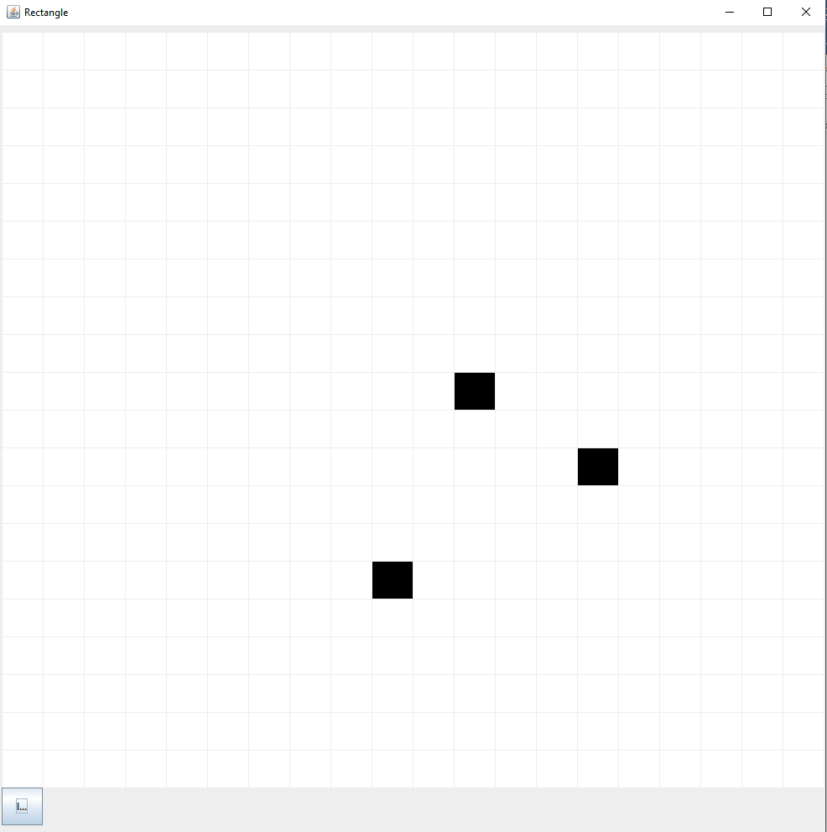

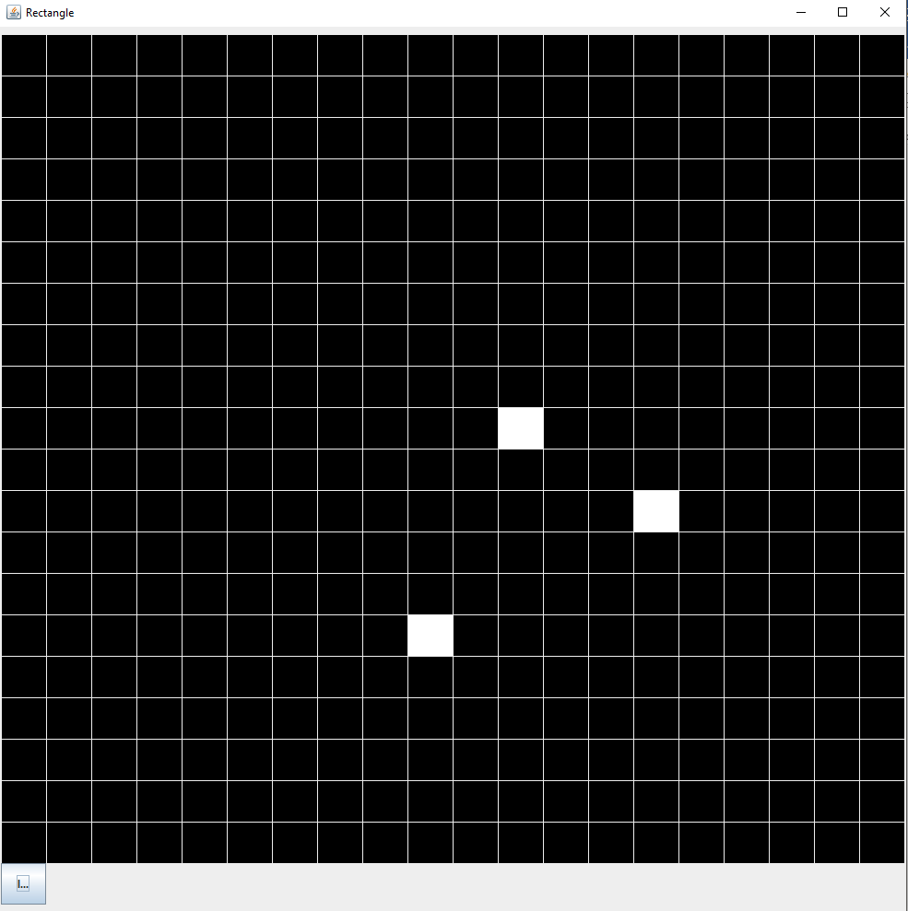

## Question 7

**import java.awt.*;**

**import java.awt.event.*;**

**import javax.swing.*;**

**public class Calculator implements ActionListener{**

**protected int c = 0, first_num = 0, val = 0, new_val;**

**JFrame frame = new JFrame("Calculator");**

**JPanel topPan = new JPanel(), botPan = new JPanel();**

**JLabel screen = new JLabel();**

**boolean bool = false;**

**public Calculator()**

**{**

**frame.setSize(200, 400);**

**frame.setLayout(new GridLayout(2, 1));**

**frame.add(topPan);**

**topPan.setSize(200, 100);**

**frame.add(botPan);**

**topPan.setLayout(new BorderLayout(20, 20));**

**topPan.add(screen, BorderLayout.CENTER);**

**screen.setOpaque(true);**

**screen.setBackground(Color.BLACK);**

**screen.setForeground(Color.WHITE);**

**botPan.setLayout(new GridLayout(4, 3));**

**for(int i = 0; i<12; i++)**

**{**

**JButton[] b = new JButton[12];**

**if(i<10)**

**{**

**b[i] = new JButton("" + i + "");**

**botPan.add(b[i]);**

**b[i].addActionListener(this);**

**}**

**else**

**{**

**if(i == 10)**

**{**

**b[i] = new JButton("+");**

**botPan.add(b[i]);**

**b[i].addActionListener(this);**

**}**

**else**

**{**

**b[i] = new JButton("C");**

**botPan.add(b[i]);**

**b[i].addActionListener(this);**

**}**

**}**

**}**

**frame.setDefaultCloseOperation(JFrame.EXIT_ON_CLOSE);**

**frame.setVisible(true);**

**}**

**public void actionPerformed(ActionEvent e)**

**{**

**if(c<10)**

**{**

**if(bool == true)**

**{**

**screen.setText("");**

**bool = false;**

**}**

**switch(e.getActionCommand().toString())**

**{**

**case "0": {screen.setText(screen.getText().concat("0")); c++;}; break;**

**case "1": {screen.setText(screen.getText().concat("1")); c++;}; break;**

**case "2": {screen.setText(screen.getText().concat("2")); c++;}; break;**

**case "3": {screen.setText(screen.getText().concat("3")); c++;}; break;**

**case "4": {screen.setText(screen.getText().concat("4")); c++;}; break;**

**case "5": {screen.setText(screen.getText().concat("5")); c++;}; break;**

**case "6": {screen.setText(screen.getText().concat("6")); c++;}; break;**

**case "7": {screen.setText(screen.getText().concat("7")); c++;}; break;**

**case "8": {screen.setText(screen.getText().concat("8")); c++;}; break;**

**case "9": {screen.setText(screen.getText().concat("9")); c++;}; break;**

**}**

**}**

**if(e.getActionCommand().equals("+"))**

**{**

**val = val + Integer.parseInt(screen.getText());**

**System.out.println(Integer.parseInt(screen.getText()));**

**screen.setText("" + val);**

**c = 0;**

**bool = true;**

**}**

**if(e.getActionCommand().equals("C")) {screen.setText(""); c = 0; /*first_num = 0*/;}**

**}**

**public static void main(String args[])**

**{**

**new Calculator();**

**}**

**}**

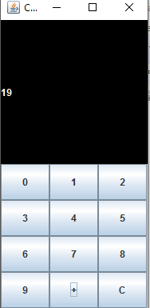

## Question 8:

**import java.awt.*;**

**import java.awt.event.*;**

**import javax.swing.*;**

**public class BaseConverter implements KeyListener{**

**JFrame frame = new JFrame("Base Converter");**

**String[] Base = new String[]{"Duodecimal", "Hexidecimal", "Decimal", "Octal", "Binary"};**

**int b1, b2;**

**char key;**

**JComboBox<String> drop1 = new JComboBox<>(Base), drop2 = new JComboBox<>(Base);**

**JTextField in = new JTextField(), out = new JTextField();**

**public BaseConverter()**

**{**

**frame.setSize(400, 200);**

**frame.setLayout(new GridLayout(2, 2, 20, 20));**

**frame.add(in);**

**in.addKeyListener(this);**

**frame.add(out);**

**out.addKeyListener(this);**

**frame.add(drop1);**

**frame.add(drop2);**

**frame.setDefaultCloseOperation(JFrame.EXIT_ON_CLOSE);**

**frame.setVisible(true);**

**}**

**public void keyPressed(KeyEvent e)**

**{**

**key = e.getKeyChar();**

**valid();**

**}**

**public void keyTyped(KeyEvent e)**

**{**

**if(valid()==false)**

**{**

**e.consume();**

**return;**

**}**

**}**

**public void keyReleased(KeyEvent e)**

**{**

**convert();**

**}**

**public void displayInfo(KeyEvent e, String keyStatus){}**

**public boolean valid(){**

**switch(b1)**

**{**

**case 12: if(key >= '0' && key <= '9' || key == 'a' || key == 'b' || key == 'A' || key == 'B')return true; break;**

**case 16: if(key >= '0' && key <= '9' || key >= 'a' && key <='f' || key >='A' && key <= 'F')return true; break;**

**case 10: if(key >= '0' && key <= '9') return true; break;**

**case 8: if(key >= '0' && key <= '7') return true; break;**

**case 2: if(key >= '0' && key <= '1') return true; break;**

**default: break;**

**}**

**return false;**

**}**

**public void convert()**

**{**

**switch(drop1.getSelectedItem().toString())**

**{**

**case "Duodecimal": b1 = 12; break;**

**case "Hexidecimal": b1 = 16; break;**

**case "Decimal": b1 = 10; break;**

**case "Octal": b1 = 8; break;**

**case "Binary": b1 = 2; break;**

**default:break;**

**}**

**switch(drop2.getSelectedItem().toString())**

**{**

**case "Duodecimal": b2 = 12; break;**

**case "Hexidecimal": b2 = 16; break;**

**case "Decimal": b2 = 10; break;**

**case "Octal": b2 = 8; break;**

**case "Binary": b2 = 2; break;**

**default:break;**

**}**

**out.setText(Long.toString(Long.parseLong(in.getText(), b1), b2));**

**}**

**public static void main(String args[])**

**{**

**new BaseConverter();**

**}**

**}**

